**Christopher King**

**2018141521058**

**Applied Fluid Mechanics**

**Class Section 01**

**03/23/2021**

# **Problem 8.78**

Water flows from a tank with a very short outlet pipe. Estimate the exit flow rate. How could the flow rate be increased?

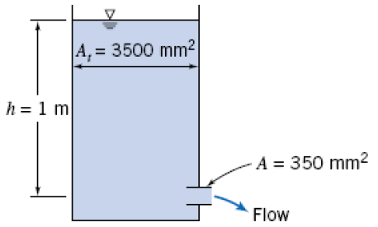

**Solution:**

Improvement:

1. Add a diffuser.
2. Round the entrance.

# **Problem 8.105**

A pool is to be filled that has a 1.5 m diameter and is 0.76 m deep. The pool is located 5.5 m above the water source which travels through a 15 m long, 1.6 cm diameter hose that is very smooth. Neglecting minor losses, how long will it take to fill if the water pressure at the source is 414 kPa?

Guess *f*=0.015:

**Solution:**

# **Problem 8.120**

Determine the smallest standard commercial steel pipe that will allow for a static pressure to be greater than -6m H2O gage.

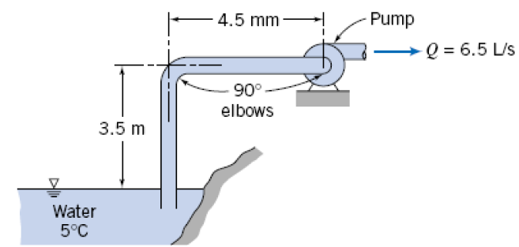

**Solution:**

From Table 8.5, I can know that the inside diameter for suitable commercial steel pipe is .

# **Problem 8.129**

Calculate the minimum pressure needed at the pump outlet for a 38 L/s flow rate and the input power required if the pumping efficiency is 70%.

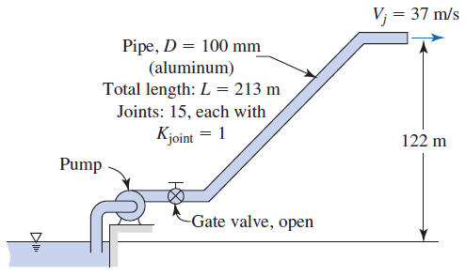

**Solution:**